DETAILED REPORT : TECH-TITANS ( Group six)

TOPIC : LIFE EXPECTANCY

**Introduction :**

This Project is based on a dataset provided by WHO and United Nations website to determine and analyze the predicting factors that contribute to a higher or lower value of life expectancy for different countries.

**Project description:**

The dataset consisted of 22 columns and 2,938 rows with 20 predicting variables.These predicting variables included Immunization related factors , Mortality factors, Economical factors, Social and other Health related factors.The data collected spanned a 15 year period starting from year 2000 to year 2015. Also, the data was taken from 193 countries which were grouped into Developed and Developing Countries. After loading the data into Power BI desktop, certain questions were derived from the predicting variables which had the potential to help us achieve our goal.

**These questions were:**

1. How does Schooling affect Life expectancy?
2. Does adult mortality rate have an impact on life expectancy?
3. Does life expectancy have positive or negative correlation with certain lifestyles such as drinking of alcohol?
4. What impact does Immunization against Diphtheria and Polio have on life expectancy?
5. What are the effects of HIV/AIDS on life expectancy?
6. Should countries below the Average life expectancy increase their Healthcare expenditure in order to improve their average lifespan?

**The Goal:**

This project aims to investigate the key factors influencing life expectancy in developed and developing countries, providing actionable recommendations for countries with low life expectancy to improve health outcomes.

**THE DATA DESIGN PROCESS**

**Step 1 : Data exploration**

We explored the data on the Power BI Desktop by inspecting all the columns and rows closely. We identified several null values,outliers and also realized 10 countries had only one year of data collection under consideration.

**Step 2: Data Cleaning and Transformation**

We transformed the data in Power Query, where we cleaned the data by changing all the null values to zero. We removed all the countries with only 1 year of recorded data and we had 183 countries with full records to work with. Poland had a null value for most of its fields for the year 2013, we replace these null values with the mean of the specific fields.

**Step 3 : Data Analysis Overview and Visualizations**

Power BI was the tool used to create the dashboard for our analysis and Data Analysis Expressions ( DAX) was used to create certain measures to enhance its visualization.

1. **Effects of Schooling on Life Expectancy**

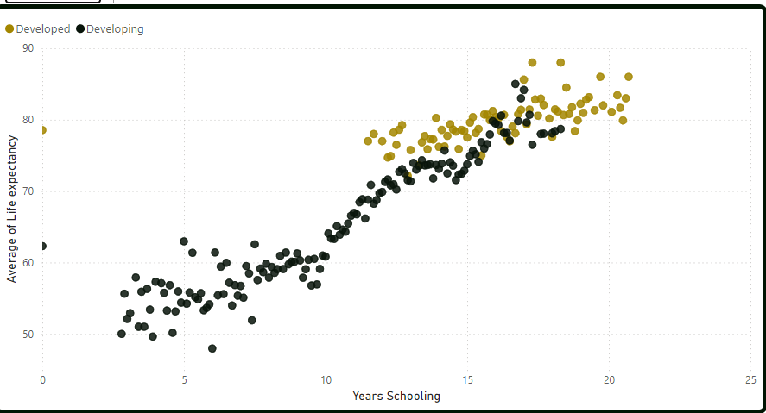

From the visual, a strong correlation exists between education and life expectancy. As individuals become more educated, they tend to adopt healthier lifestyles, make informed health decisions, access better healthcare, etc and as such schooling affects life expectancy positively. Also, the percentage of schooling in developed countries is higher than that of developing countries and the chart clearly shows most Developed countries having a higher life expectancy rate comparatively.

1. **Effects of Consuming Alcohol on Life Expectancy**

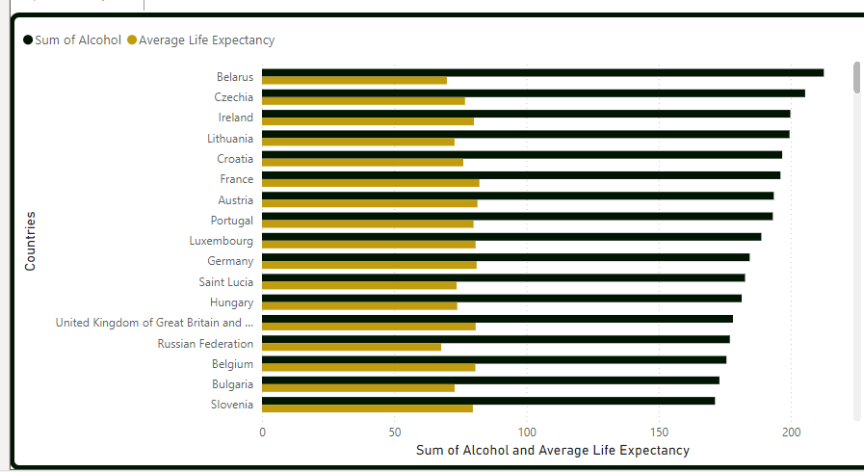

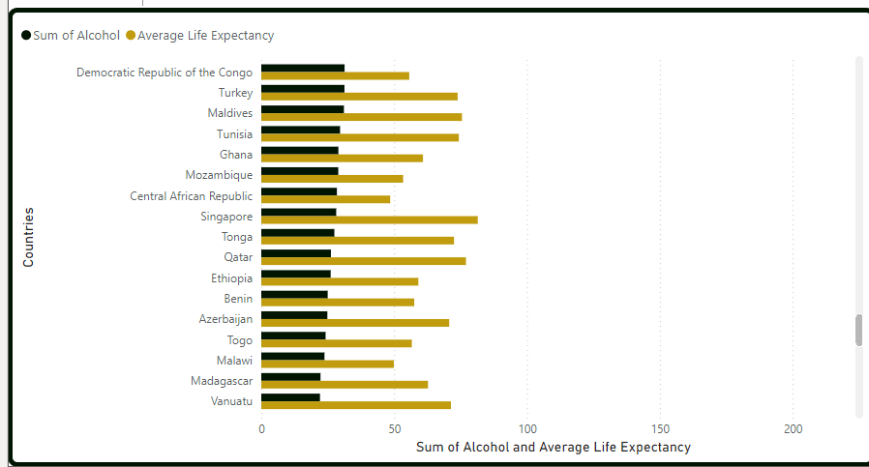

As countries are educated, they tend to know the negative effects of alcohol on their life. From the visual, alcohol has a negative correlation on life expectancy. As the value for alcohol consumption increases, life expectancy decreases respectively. The chart shows that Belarus, Ireland, etc consume alcohol at a higher rate and they have low life expectancy values. However, countries like Togo and Malawi are able to live longer because their alcohol consumption is low.

1. **Effects of Adults Mortality on Life Expectancy**

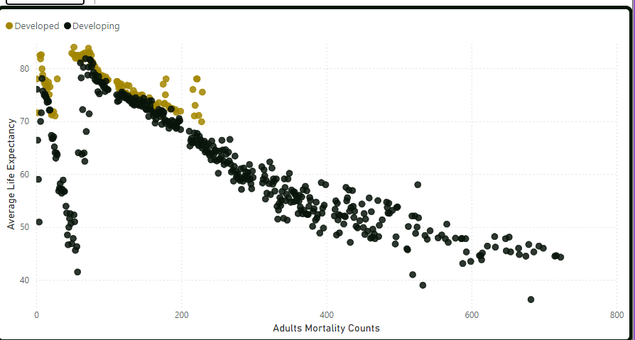

Adult mortality rate is the probability of dying between the ages of 15 and 60 years per 1,000 population.

From the scatter plot above we could say that adult mortality has a negative correlation with life expectancy, therefore the more adults we have dying in a particular country, the less their life expectancy. From the above visual, developed countries have lower adult mortality rate, hence have higher life expectancy. The developing countries have higher adult mortality rate and lower life expectancy.

1. **Effects of Immunization on Diphtheria and Polio on Life Expectancy**

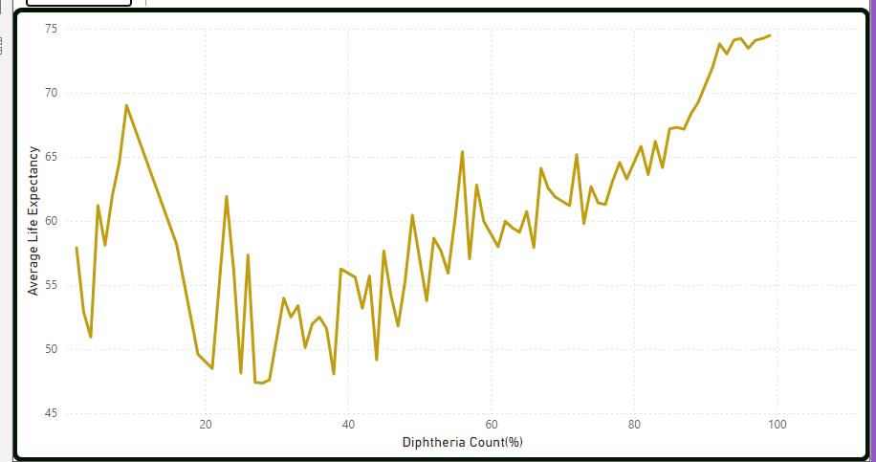

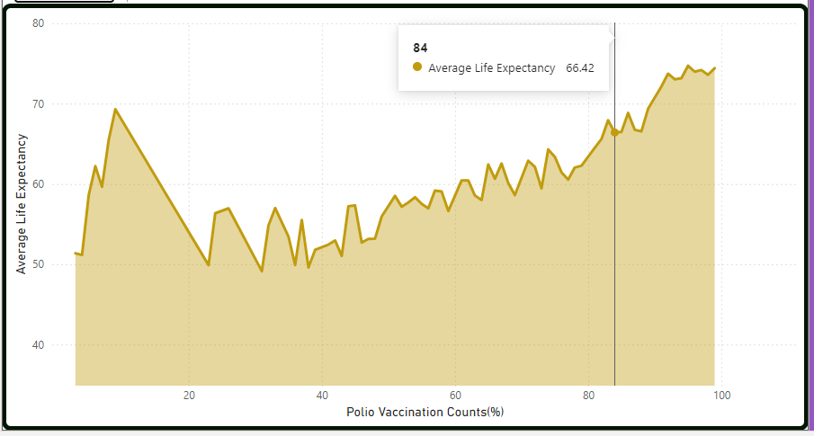

Looking closely at the number of Immunizations against Diphtheria and Polio it can be observed that countries with a higher rate of Diphtheria and Polio Immunization have higher life expectancy values except for exceptional cases which could be due to incorrect data and some outliers.

It can be concluded that as the number of immunizations is increased per population over time their life expectancy also increases showing a positive correlation.

1. **Effects of HIV/ AIDS against Life expectancy**

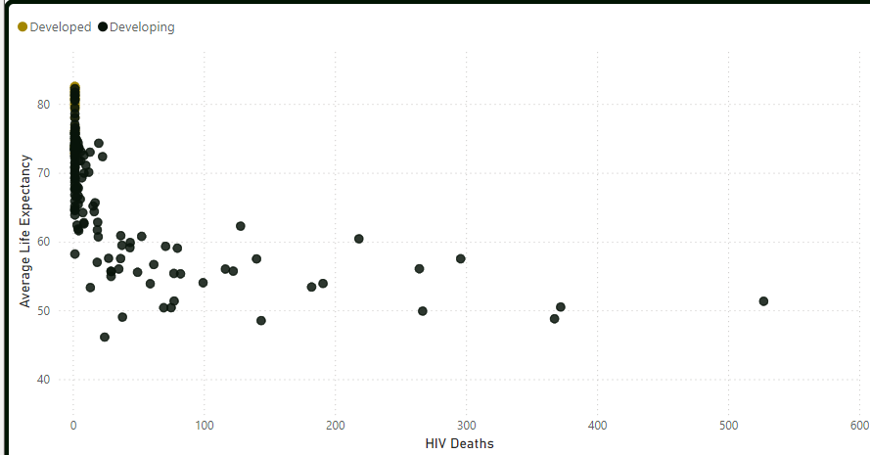

From the above scatter plot,the correlation between HIV/AIDS death and life expectancy chart shows whether HIV/AIDS deaths are a contributing factor to the average life expectancy of the countries captured in the dataset for the period analyzed. It highlights a movement from the upper left towards the right, showing a negative correlation. This means an increase in one will lead to a decrease in the other. Insight: HIV/AIDS deaths negatively impact life expectancy and from the scatter plot, it can be seen that the majority of the countries have a higher average life expectancy because they have few to no HIV/AIDS deaths. We could say that these countries have put in place preventive and curative measures against HIV/AIDS. Another insight drawn was in relation to how only 1% of HIV/AIDS cases could be attributed to Developed countries, telling us that 99% were from Developing countries. Recommendation: The countries that fall in the extreme can be assisted with resources to help minimize HIV/AIDS deaths and increase life expectancy.

**Effects of Economic factors on Life Expectancy**  
**A. GDP & Life Expectancy**  
The scatter plot shows a positive correlation between GDP and average life expectancy, with life expectancy rising as GDP increases, particularly at lower GDP levels. However, the relationship plateaus around a GDP of 200K-400K, where life expectancy stabilizes near 80 years. This suggests that beyond a certain GDP threshold, additional increases in wealth have diminishing returns on life expectancy.  
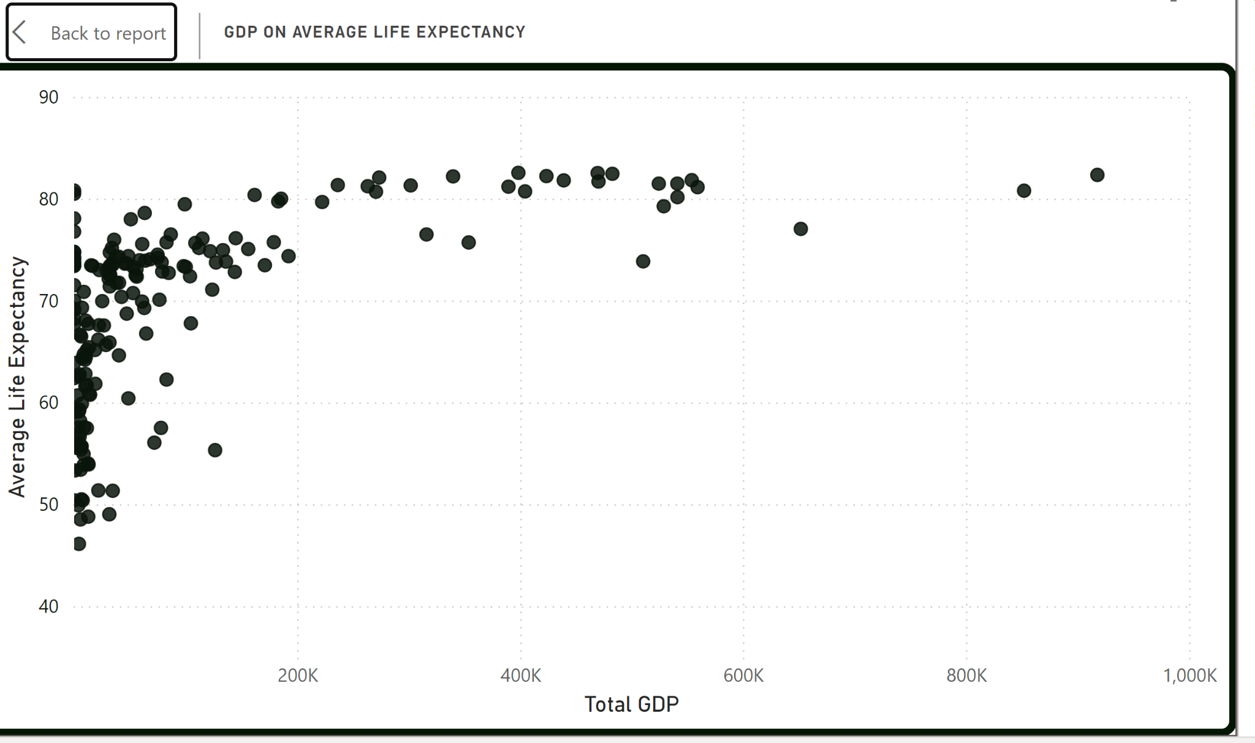

**B.Expenditure & Life Expectancy**

The image below shows a weak and scattered relationship between total expenditure and average life expectancy. While some clusters suggest that higher expenditures may slightly correlate with increased life expectancy (around 70-80 years), the data points are widely spread, indicating a less consistent pattern. This suggests that factors other than expenditure may play a significant role in determining life expectancy.

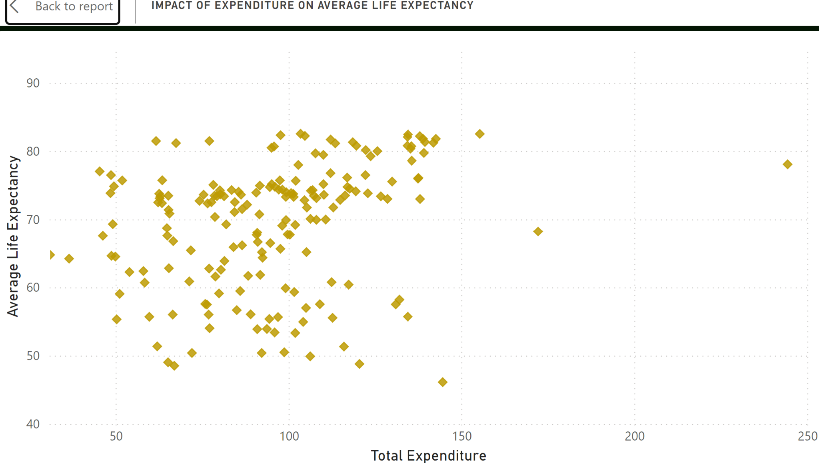

**C.Income composition of Resource & Life Expectancy**  
The scatter plot below shows a positive correlation between income composition of resources indexes and average life expectancy. As the income composition increases, there is a general upward trend in life expectancy, indicating that countries with higher income resources tend to have longer life expectancies. However, the relationship becomes more distinct at higher levels of income composition, with fewer outliers.

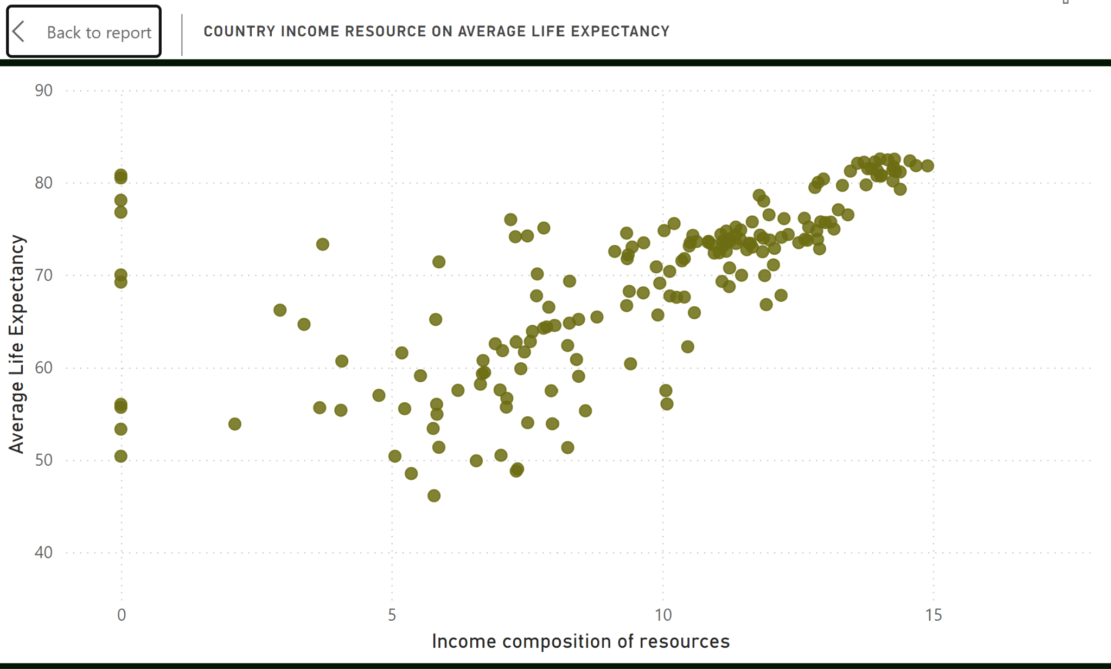

In summary, economic factors, such as total expenditure and income composition of resources, positively impact life expectancy, as shown by the upward trends in both graphs. Countries with higher expenditures and better income resources generally experience longer life expectancy.

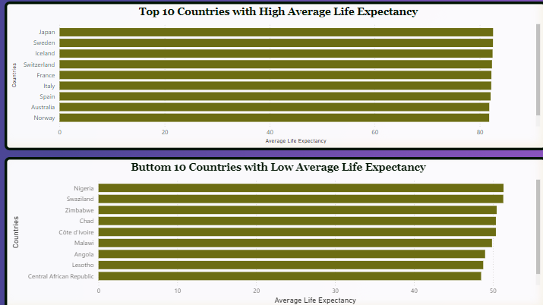

**RECOMMENDATIONS :**

Key insights: In developed countries,we realized there was a higher schooling rate, and their higher economic values showed a positive relationship with their healthcare needs. Hence we assume that they invested their economic returns into these areas.

Therefore, if developing countries having higher mortality rates should tailor their resources to their health sector then their life expectancy is expected to increase overtime.

**Group Members: Tech- Titans**

1. Halima Saadia
2. Khadijah El - Alawa
3. Quansah Comfort
4. Arthur Linda
5. Duodu Felix